WEST LONDON WASTE AUTHORITY
Report of the Projects Director | 23rd September 2022
Projects and Circular Economy Update
SUMMARY
This report provides an update on the WLWA projects.

RECOMMENDATION(S)

- The Authority is asked to note the information within this report.

- Introduction
This report covers the main project updates with governance of the wider programme managed through the WLWA senior leadership team.

- Project Development
The delivery of the programme has been split into six key areas (Data Management, Smart Cities, HRRC transformation, Food Waste, Shared EPR funding plan, Double Recycling infrastructure) each with an Environment Director and Member lead. Policies were agreed in March 2022 and strategy on a page documents are being jointly developed in order to deliver a unified approach to whole system change.

2.1 Waste Composition Analysis (contribute to KPI’s 5 6 & 7)
The 2022 waste composition analysis (WCA) has been awarded to Integrated Skills Ltd (ISL), the company that conducted WCA last year. The sample selections and detailed scheduling of the work are currently being finalised. The sampling of the residual waste will take place towards the end of September and we anticipate the results to be finalised and shared in October / November. ISL will also revisit the data from WCA in 2020 and re-evaluate using the same methodology so that we can establish a consistent dataset.
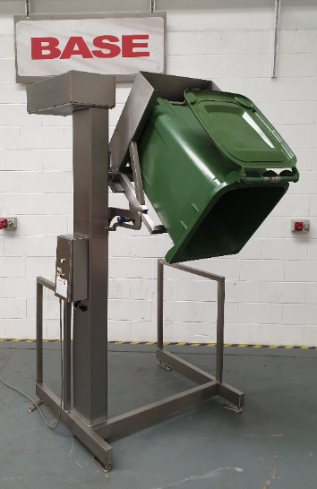
2.2 Bin Wash & Swap Station at Transport Avenue (contribute to KPI’s 5 6 & 7)
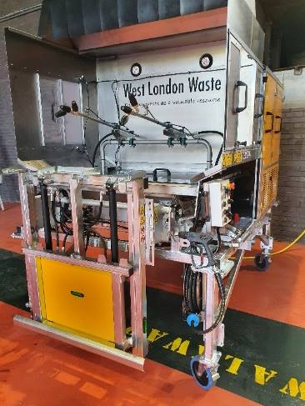
During the food value stream mapping exercise boroughs identified that a food bin ‘swap & wash’ collection system could increase service availability and efficiency. Used as best practice in the commercial food waste sector, this service model overcomes the perception of the service being dirty, a significant barrier to communal property participation. By regularly cleaning the food waste bins, it will reduce the chances of vermin and insects being attracted to the bins, reduce smells during summer months and provide a better overall experience for residents in communal bin rooms or areas. This model will provide a template for other borough partners to expand and improve food recycling collection services in future.
Working with Suez, an unused section of Transport Avenue was identified for the washing area. This equipment will be operated and serviced by Suez as part of the existing contract.

- Net Zero & Circular Economy
  - Fixing Factory (contribute to KPI 5 & 6)
The fixing factory which was launched in April at the Abbey Road Household Reuse and Recycling Centre in partnership with the Restart Project is now up and running with regular schedules and monthly events. The Factory is now collecting devices from 3 recycling centres and has so far checked 90 devices; donated 10. There is a repair rate of 30% and we are expecting this rate to improve over time. Monthly repair sessions have been running since June (4 sessions taken place so far) with over 50 attendees.

  - Material Diversion from Abbey Road HRRC (contribute to KPI 5 & 6)
Bicycles
- We’ve been collecting bicycles from Abbey Road (Brent) and Townmead Road (Richmond) and have engaged with several partners
- Officers are seeking to expand the collection from all HRRCs where possible
- Let’s Ride Southall = 155 bikes donated to be given to residents as part of London’s biggest inclusive cycling programme
- Feltham Young Offenders = 35 bikes given to their workshop, awaiting repairs
- Pathways Education = currently speaking with them to use our bike workshop at Abbey Road, teaching students with special learning requirements
- Sustrans = 16 bikes donated
- Hounslow Police = 5 bikes donated
Buggies, suitcases & disability equipment etc
- We are also supporting Little Village, Care4Calais, and One Nation. Over 200 items have been diverted, helping over 60 families. This includes suitcases and buggies for refugees and struggling families and disabilities equipment for victims of war abroad.
- We will be partnering with NHS to also start collecting walking aids
We are currently mapping out the process and protocols for starting and developing material diversions which could be shared with the Boroughs

  - ReLondon Pan-London Food Campaign (contribute to KPI 5, 6 & 7)
ReLondon has engaged with over 20 London Boroughs to run a London-wide food campaign. Three of our Boroughs are contributing to this project and WLWA has therefore been involved in the working group to ensure our needs and feedback are given to shape the project. The primary objectives of the project is to encourage a less carbon-intensive, more plant-based diet; and to reduce household food waste.

  - Circular Economy Hubs (contribute to KPI 5, 6 & 7)
WLWA Officers are scoping the opportunities with Ealing and Brent Councils and with third parties in Harrow and Hillingdon for Circular Economy Hubs.
In addition to this WLWA Officers are working with Hounslow on neighbourhood specific Circular Economy services.

3.4 Abbey Road Decarbonisation
The grid capacity testing, building and electrical surveys, Health and Safety reviews have been completed with the installation of solar panels at Abbey Road due to start by the end of September.

- WLWA Communication Strategy / Plan
The Communication Strategy has been drafted and is currently being consulted widely with the Boroughs. We are aiming to establish consistent and regular communication managed at west London level to promote waste, recycling and wider climate emergency matters. We are convening the west London Communication board consist of representatives from Boroughs’ Comms teams to shape and support the implementation of the Comms Plan.

- Risk
New legislation and details regarding EPR, DRS and the Environment Act, that will impact on all waste services are expected soon. Officers are seeking to identify potential impacts and factor these in during the development of all projects.
This includes significant work on data and collections systems to help inform whole system impacts of future legislation such as consistency of collection.

- Financial Implications
WLWA projects are designed to test and change the whole system to deliver benefits financially, environmentally and socially. Due to the whole system approach, there are aspects of the delivery and returns that require significant partnership working and multiple stakeholder changes, as such absolute returns are modelled, risk assessed and tracked but cannot be guaranteed.
The solar panel cost has increased by just under £5000, in line with the increase in the cost of energy and fuel, the solar panel and EV project returns have improved improve due to the increased off-set versus energy from the grid or diesel usage. All other projects are currently within approved budgets and project parameters.
- Staffing Implications – Projects and Circular Economy Team are currently under resourced with two members of staff (CE Manager and a Project Officer) on maternity leave since May. An additional member of staff has served their notice to leave WLWA by the end of Sept.
Whilst we are currently in the process of interviewing for the maternity cover roles and initiating the recruitment for the Circular Economy Engagement Officer.
- Health and Safety Implications – All fieldwork has been risk-assessed for the tasks to be completed. In order to improve the way, the H&S is addressed across all third party projects, we are currently developing a protocol / workflow to map out how to address H&S and engage with the H&S advisor(s).
We are currently reviewing the current H&S guidance around working with Vulnerable People at Abbey Road to enable us to provide opportunities (work experience, site visits/educational) for them to visit the site. This is addressed by the separate agenda item, “Health and Safety Policy and Guidance change”.
Additional Health and Safety training is being planned for the team to ensure all members are informed to a standard to help raise awareness on site visits.
- Legal Implications - none
- Joint Waste Management Strategy
The projects mentioned in this report are intrinsically linked to the Authority’s Joint Waste Management Strategy. The projects are driving the design of the new policy through data, best practice and identification of opportunities, as well as delivering change to meet the desired outcomes and targets in the Strategy.

Contact Officers | Peter Tilston, Projects Director 07796 271 713  petertilston@westlondonwaste.gov.uk  Motoko Doolan, Net Zero Carbon Manager 07917 075 876  motokodoolan@westlondonwaste.gov.uk  Sarah Ellis, Strategic Development Lead 07584 631 710  sarahellis@westlondonwaste.gov.uk

